This is an example of article title for the MIRG-ICAIR Paper Submission. It should be clear and Concise.

Kingsley ‘Et Abang¹, Asuquo Effiong Hanson², Tomilade Oluwatosin Ogunyele³,
and Chinedu Chinonso Eme⁴
¹Department of Business Administration, University of Lagos, Akoka
²Department of Religious and Cultural Studies, University of Calabar, Calabar
³Department of Educational Technology, University of Ibadan, Ibadan
⁴Department of Philosophy, University of Nigeria, Nsukka

Abstract
This is an example of the abstract for your paper. It should be unstructured but include key elements such as the background, problem/gap, method, results/finding, and implications and be between 150 to 200 words in length. The abstract should have 0.5 cm left and right indentation and in 1.15-line spacing. This is an example of the abstract for your paper. It should be unstructured but include key elements such as the background, problem/gap, method, results/finding, and implications and be between 150 to 200 words in length. The abstract should have 0.5 cm left and right indentation and in 1.15-line spacing. This is an example of the abstract for your paper. It should be unstructured but include key elements such as the background, problem/gap, method, results/finding, and implications and be between 150 to 200 words in length. The abstract should have 0.5 cm left and right indentation and in 1.15-line spacing. This is an example of the abstract for your paper. It should be unstructured but include key elements such as the background, problem/gap, method, results/finding, and implications and be between 150 to 200 words in length. The abstract should have 0.5 cm left and right indentation and in 1.15-line spacing.
Keywords: Provide 3 to 5 keywords in alphabetical order, separated by comma.

1. Introduction
This is an example text for the introduction. It should be very clear and provide a strong rationale and justification for the paper. Authors should use recent literature to provide justification for the originality and novelty of their paper. All citations should be done in APA 7. The paragraphs can be either justified or left aligned and in 1.5-line spacing as with this example (Abang et al., 2026).

2. Literature Review
MIRG-ICAIR allows a free-formatted manuscript submission. Authors can use the format that best fit their article type depending on if it is an empirical article, conceptual/theoretical paper, review articles, practitioners’ insights, etc. However, all paper should include a sound introduction, literature review as the case may be, methodology, results/findings, as well as discussions and implications. Hence, headings and subheadings will reflect the peculiarities of each submission. However, headings should not have more than 4 levels and should be presented aptly.
All figures should be in high resolution and not be created with generative AI. Sources of all figures should be stated. If the figures were created by the author, the source should read “Authors’ creation”.

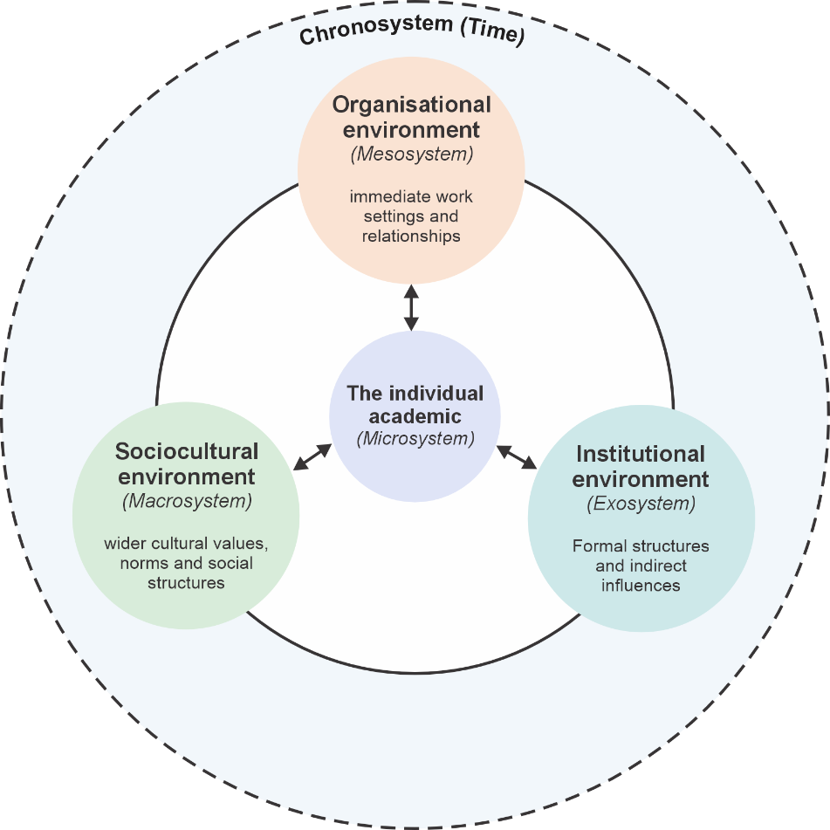

Figure 1. This is an example of a figure heading. Source: Authors’ creation (2026)

3. Methods
This is an example of how to format headings

3.1 Heading level 2
This is an example of heading level 2; the main heading being level 1.

Heading level 3
This is an example of heading level 3

Heading level 4. This is an example of heading level 4

4 Results
Below is an example of how to present your table.

Table 1. Multilevel ecological framework for responsible AI use among academics
Ecological level | Role in the framework | Supporting studies
Individual/dispositional. What does the academic bring to the AI-use situation? | Individual capabilities, orientations and experiences shape how academics understand, evaluate and act on AI. | Lintner (2024); Liu (2025); Acosta-Enriquez et al. (2025a, 2025b)
Organisational. What does the academic experience in the immediate workplace? | Everyday organisational signals shape what AI use is expected, supported, discussed and accepted. | Abang (2025); Abang & Oluwafemi (in press); Acosta-Enriquez et al. (2025a)
Cross-level interactions. What happens when conditions across levels reinforce, contradict or align? | Responsible AI use emerges through the interaction of levels. Reinforcement can strengthen expectations, contradiction can create ambiguity, and alignment can make responsible practice clearer and more practicable. | Nguyen et al. (2026); Sturm et al. (2026)
Source: Authors’ creation (2026)

5. Conclusion and Implications
Ethical, funding, conflicting interest and data availability statements/declarations should be included as applicable at the end of your manuscript text before the References. We do not accept the use of generative AI for manuscript development, creation of figures or any writing of the article, however if you use any genAI tool for editing and enhancement of the writing for clarity, you will need to declare this. All references should be prepared using APA version 7 as with the example below with all DOIs provided where available to enable easy verifications of all references.

Ethical statement. As the study did not include any human subject, formal ethical approval was not required.

Funding. This study was funded in part by the Starthubvarsity AfriBusiness Technology Research Initiative. Grant No SABTR/2026/01.

Conflicting interest. The authors have no conflict of interest to declare.

Use of generative AI. ChatGPT v5.6, was used in the editing and enhancement of the grammar and clarity of this paper. However, the ideas, arguments, conceptual framework, interpretations and final content are entirely those of the authors, who retain full responsibility for the accuracy, integrity and final version of the paper.

References
Abang, K. E. (2025). Organisational climate and intention to use generative artificial intelligence among academic staff of a Nigerian university: The mediating role of perceived usefulness. In V. Odumuyiwa, & O. Sennaike (Eds.), Proceedings of the 5th International Conference on Artificial Intelligence and Robotics (pp. 1–12). Machine Intelligence Research Group, University of Lagos.
An, Q., Yang, J., Xu, X., Zhang, Y., & Zhang, H. (2024). Decoding AI ethics from Users' lens in education: A systematic review. Heliyon, 10(20), e39357. https://doi.org/10.1016/j.heliyon.2024.e39357
Aronson, J. K. (2025). When I use a word...“Publish or perish”: problems and solutions. BMJ, 390. https://doi.org/10.1136/bmj.r1629
Brown, V., Larasati, R., Kwarteng, J., & Farrell, T. (2026). Understanding AI and power: Situated perspectives from Global North and South practitioners. AI & Society 41(4), 3981-3996. https://doi.org/10.1007/s00146-025-02731-x
Cao, K., Wang, P., & Zhao, J. (2025). The moderating role of ethnic culture on adoption intention of generative artificial intelligence among university students. Frontiers in Education, 10, Article 1622620 https://doi.org/10.3389/feduc.2025.1622620
Fu, Y., & Weng, Z. (2024). Navigating the ethical terrain of AI in education: A systematic review on framing responsible human-centered AI practices. Computers and Education: Artificial Intelligence, 7, 100306. https://doi.org/10.1016/j.caeai.2024.100306
Mekheimer, M., & Abdelhalim, W. (2026). Artificial intelligence in academic publishing and the faculty tradeoff between productivity benefits and academic integrity concerns. Discover Sustainability, 7(1), 1212. https://doi.org/10.1007/s43621-026-04243-0
National Universities Commission. (2026, January 11). ES renews commitment to pursuing NUS roadmap in 2026 https://www.nuc.edu.ng/es-renews-commitment-to-pursuing-nus-roadmap-in-2026/
Nazir, T. 2026. An Ecological Systems Analysis of University Students' ChatGPT Use in Higher Education. Systems Research and Behavioral Science 1–18. https://doi.org/10.1002/sres.70108.
Ruttkamp-Bloem, E. (2023). Epistemic just and dynamic AI ethics in Africa. In D. O. Eke, K. Wakunuma, & S. Akintoye (Eds.), Responsible AI in Africa: Challenges and opportunities (pp. 13–34). Palgrave Macmillan. https://doi.org/10.1007/978-3-031-08215-3_2
Schneider, B., Ehrhart, M. G., & Macey, W. H. (2026). Organizational climate and culture: History, current status, integration, and change. Annual Review of Organizational Psychology and Organizational Behavior, 13(1), 309-335. https://doi.org/10.1146/annurev-orgpsych-020924-070545
Şen, E., Vaněček, D., & Adnan, M. (2026). Balancing regulation and innovation: the need for agile AI governance in higher education – a cross-country study. Studies in Higher Education, 1–18. https://doi.org/10.1080/03075079.2026.2614986
UNESCO-ICHEI. (2025, August 15). Case sharing of the 2025 IIOE Pioneer Award ③. https://cn.ichei.org/en/news/information/1365.html
United Nations Educational, Scientific and Cultural Organization. (2022). Recommendation on the ethics of artificial intelligence. UNESCO Digital Library. https://unesdoc.unesco.org/ark:/48223/pf0000381137
Yan, Y., Liu, H., & Chau, T. (2025). A systematic review of AI ethics in education: Challenges, policy gaps, and future directions. Journal of Global Information Management (JGIM), 33(1), 1-50. https://doi.org/10.4018/JGIM.386381
Zhang, H., Hong, Y., & Li, J. (2026). The Transformation of University English Teacher Identity in an AI-Integrated Classroom from an Ecological Perspective: A Systematic Literature Review. Education Sciences, 16(8), 1-37. Article 1305. https://doi.org/10.3390/educsci16081305

Corresponding author. Email: kingsley.abang@live.unilag.edu.ng; Phone Number: 08022977968 (add this by using the footnote feature).

